User Documentation

# Project summary

The Code Duplication Checker is a tool which can detect duplicate code or "code clones." The project is written in C# and works for the C# code bases. We categorize the code clones in 4 types and the tool can detect all the 4 different types.

Type-1: Identical code fragments except for variations in whitespace, layout and comments.

Type-2: Syntactically identical fragments except for variations in identifiers, literals, types, whitespace, layout and comments.

Type-3: Copied fragments with further modifications such as changed, added or removed statements, in addition to variations in identifiers, literals, types, whitespace, layout and comments.

Type-4: Two or more code fragments that perform the same computation but are implemented by different syntactic variants.

# How to use Code duplication checker.

Code duplication checker comes with a simple windows form UX which takes a path to the repo and runs a code duplication checking algorithm. The results can be viewed within the forms UX as a table where each row represents a comparison between the two methods and score representing how much of code is duplicated.

The score is normalized between 0 and 1, where 0 represents and exact match and 1 represents the opposite. The results in the table are sored by the score in ascending order.

To Run the Code duplication application, follow the below steps

## Step 1 : Clone and build the repo.

Clone the repo and build the code locally. Follow the [Developer Documentation](https://github.com/jennifergalley/CodeDuplicationChecker/blob/master/DeveloperDocumentation.md) on how to setup the code on your machine and build it.

### Step 2: - Run the Code Duplication checker application

Once the code is setup locally and the build is successful, find “CodeDuplicationCheckerApp.exe” in path *CodeDuplicationCheckerApp\bin\Debug.* Run the exe which should start the UX.

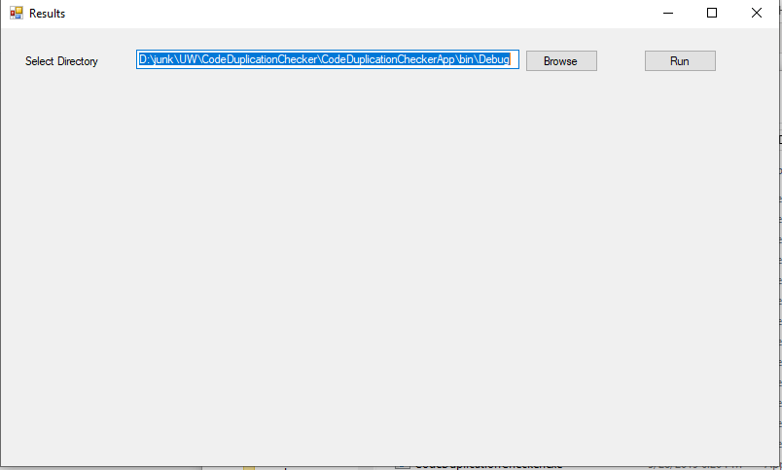

## Step 3: Run the Code duplication checker

Use the browse button and select the folder where you code resides on which you want to run the code duplication checker and click the run button.

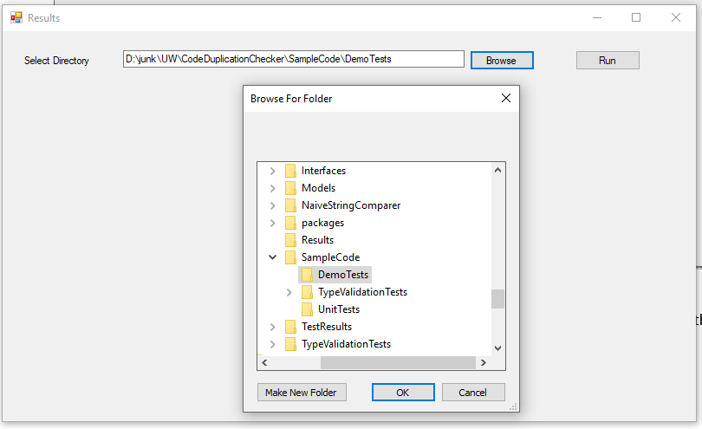

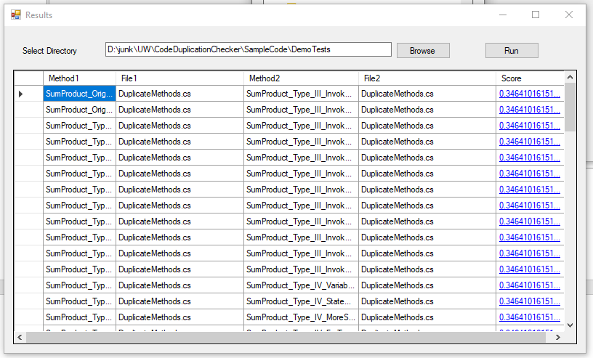

## Step 4: Analyze the results

Once the application runs and identifies all the code duplications, the results are displayed in the table. Each row represents two methods which were compared and a score/confidence of how much of an code duplication the two methods contain.

Click on the score link to actually see the diff or the duplication in a simple HTML view, where the highlighted part shows only the difference between the two methods

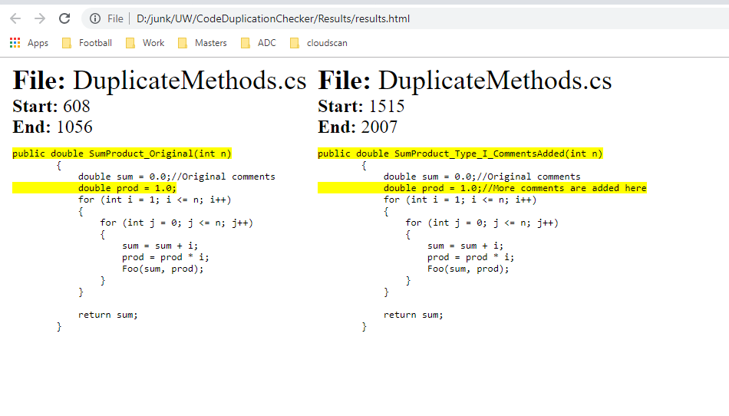

# Use cases

In our day to day development life we see our code bases exploding in terms of number of lines of code added and when there are group of people working together there is a huge chance that the code would be duplicated and we would not be aware of it. Code duplication checker would help in this perspective to and come in handy to compare the lines of code across the projects and help minimize the code base.

This application can be run as a part of code build which would help developers to identify any duplicated code and help them reuse the existing code or methods.